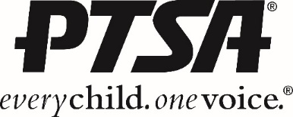

**REFLECTIONS ART PROGRAM**

6-12th grade students are encouraged to submit original works of art in one or more of the following categories:

**Dance Choreography/Film Production/Literature/Musical Composition/Photography/Visual Arts**

Any students with disabilities may receive special accommodations by entering the

special artist division and are encouraged to enter any category.

**REFLECT on the theme. CREATE art. BE RECOGNIZED!**

**\*\*\*\*\*\*\*\*\*\*\*\*\*\*\*\*\*\*\*\*\*\*\*\*\*\*\*\*\*\*\*\*\*\*\*\*\*\*\*\*\*\*\*\*\*\*\*\*\*\*\*\*\*\*\*\*\*\*\***

**How to Participate**

**Decide what type of art you want to create**. You can enter more than one category, so if you want to enter a photograph and write a poem, go for it!

**Think about this year’s theme, “What is your story?,”** and how you will express the theme in your art. When judges look at your work, the most important thing they will consider is how well it connects to the theme and your artist statement.

**Read the General Participation Rules AND the Category Rules** for the individual art category you have chosen. Rules can be found outside the PTSA office or online at the link below.

*Please note that the size limit for Visual Art and photography entries (including matting) is a maximum of 18" x 24".*

**Complete an entry form**. The 2016-2017 Entry Form can be found outside the PTSA office or online using the link below.  *The Entry Form must be signed by both a parent and the student, and attached to the artwork* in a plastic sleeve.

**Turn in your art, along with a completed Entry Form by Due date**

Online link: Www.xxxxxx

Questions: Contact person by email: ccccc

Bellevue middle and high school students have won the state and national competition in this program.