FREE to ALL BSD students with student ID CARD
$20 for BSD adults
$40 for out of district attendees
Reservation needed. Register online or at the door.

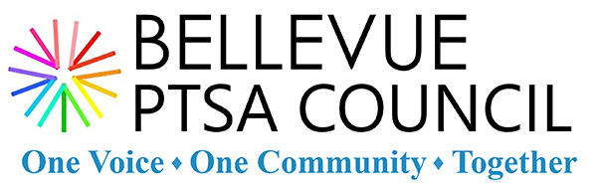

NEW Student Workshops for College Prep - Grades 8 to 11
The Bellevue PTSA Council, Bellevue Gifted Alliance, and Transcend Academy present a series of exciting NEW college prep workshops geared toward students in grades 8 to 11.

April 15
Wilburton Instructional Service Center
Rainier Room
6:30 p.m. to 8:00 p.m.
I. Top 10 Things Colleges Look for in Admissions and How to Get There
- Why Transcripts Matter: Grades and Classes
- Passionate Involvement in Activities is Key
- A Well-Written, Authentic Essay Speaks Volumes
- Demonstrated Interest in Colleges is Increasingly More Important
April 29
Wilburton Instructional Service Center
Rainier Room
6:30 p.m. to 8:00 p.m.
II. Rocking Standardized Tests
- General SAT, ACT, and Standardized Test Taking Tips
- Timing Strategies for Students
- Practicing Strategies in Session
- Tips for the Week of and Day of the Test
May 14
Newport High School
Library
6:30 p.m. to 8:00 p.m.
III. How to Write an Unforgettable Essay
- Uncovering an Authentic Story for Each Student
- Reflect on Events, Accomplishments, and Goals
- Working with Friends and Family to Get Feedback
- Using Words to Paint a Beautiful Story
May 28
Wilburton Instructional Service Center
Rainier Room
6:30 p.m. to 8:00 p.m.
IV. How to Find Your Passion
- Life is a Journey. Appreciate the Journey.
- Who You Are Will Change Through High School and College
- Craft a Personal Resume that Works for You
- How Joining Activities Can Help You Find Your Passion
About Transcend ACADEMY CEO Tina Tran Neville
As a high school teacher in private and public high schools in Washington, DC and a first-generation college student, Transcend Academy Founder Tina Tran Neville witnessed an urgent need for additional high-quality test preparation and college advising services. In 2010, Tina launched Transcend Academy to create educational content that improves diverse students' chances for college admissions. Since then, the company has expanded from in-person standardized test preparation classes, to online college admissions coaching services, to online English language learning to reach international markets. In 2018, Transcend Academy was awarded the Best Education Company in Washington, DC for their work with the majority of high schools in the region. Tina has led national workshops for College Summit and read essays for the College Board. Prior to the field of education, Tina was an U.S. Foreign Service Officer promoting education and culture exchanges with the U.S. Department of State. Tina received her B.A. from the University of Tulsa and her M.A. from Yale University. She lives in Seattle with her husband and two young children.

